# **Day 2 (9th October) : Getting into DevOps**

# **_Pre-requisites needed to be downloaded**

1. VirtualBox 6.x

2. Download ISO of CentOS 7

Need to configure CentOS in Virtual Box.

# **_What is Linux ?**

1) Linux is an open-source operating system. The source code of Linux is easily available for everyone.

2) Linux provides security. Older computer systems can be revived using Linux.

3) Software can be updated using Linux.

4) Customization can be done using Linux.

5) Various distributions can be done using Linux.

6) Linux is free to use.

7) The cost of Linux is low.

8) Linux has large community support.

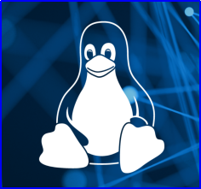

# ****_Quick overview of package managers in Linux System and Repositories****

****1) Yellow Dog Updater, Modified (YUM)****

* YUM is the primary package management tool for installing, updating, removing, and managing software packages Linux.
* It performs dependency resolution when installing, updating, and removing software packages.
* Managing packages in Linux with YUM command.

# yum -option command



****2) RPM Package Manager (RPM)****

* RPM is another popular package management tool in Linux.
* Using RPM, you can install, uninstall, and query individual software packages.

# rpm -option command



****3) Debian — Advanced Package Tool (APT)****

* Apt (Advanced Package Tool) package management system is a set of tools to download, install, remove, upgrade, configure and manage Debian packages.
* It manages all software installed on a Debian system.

These packages are distributing many software and updates with the help of repositories.

Every repository has two things .

1) Package Metadata

2) Package — Package dependencies

# ****_Difference between RPM and YUM****

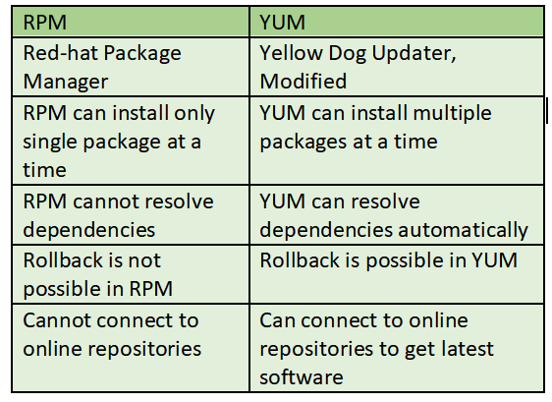

# ****_Different flavors/versions of Linux****

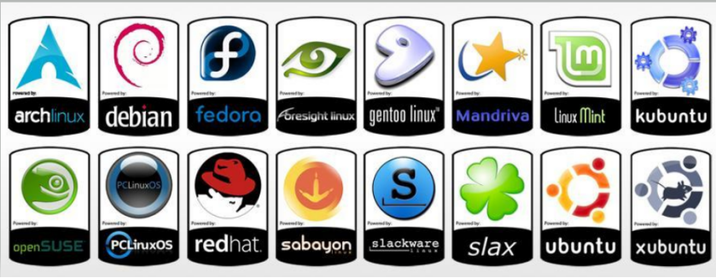

# ****_Architecture of Linux****

The Linux architecture is largely composed of elements such as the Kernel, System Library, Hardware layer, System, and Shell functions.

****1) Kernel****

A kernel is a computer program and is the central, core part of an operating system. It manages the operations of the computer and the hardware, most notably memory and CPU time. It is an integral part of any operating system.

****2) Hardware****

Physical parts of a computer, such as central processing unit (CPU), monitor, mouse, keyboard, hard disk and other connected devices to CPU.

****3) Shell****

Shell is an environment in which we can run our commands, programs, and shell scripts. It is a user interface for access to an operating system’s services.

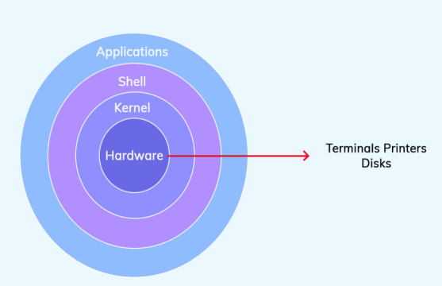

# **_What is virtualization?**

* Virtualization is the process of creating a virtual version of something like computer hardware.
* By virtualization we can simulate hardware functionality.
* Hypervisor is responsible for virtualization.

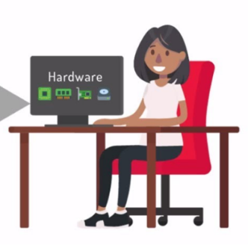

# **_What is a hypervisor?**

A hypervisor is also known as a virtual machine monitor (VMM). It is a software that creates and runs virtual machines (VMs).

A hypervisor allows one host computer to support multiple guest VMs by virtually sharing its resources, such as memory and processing.

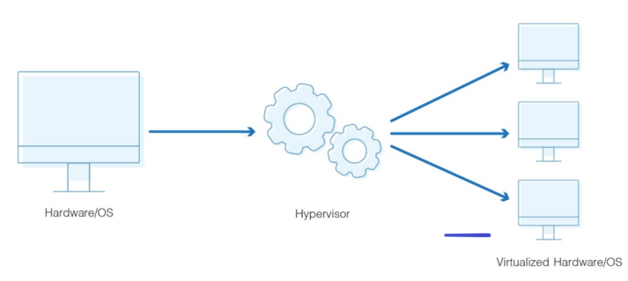

# **_Types of Hypervisors**

****1) Type1 Hypervisor****

The Type 1 hypervisor is installed and runs directly on top of the server hardware platform. This type is referred to as either bare-metal or native hypervisors.

****2) Type 2 Hypervisor****

The Type 2 hypervisor is installed as an application on an already existing operating system and allows to install the VMs in the application.

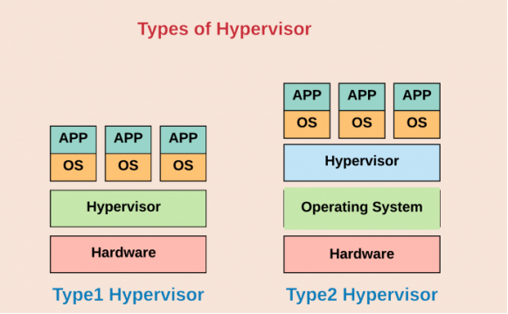

# **_Basic commands in Linux**

****1) cd****

To navigate through the Linux files and directories, use the ****cd****command.

****2) ls****

The****ls**** command lists files and directories within a system.

****3) ls -l****

The ****ls -l**** command shows file or directory, size, modified date and time, file or folder name and owner of the file, and its permission.

****4) pwd****

The ****pwd****command is used to find the path of your current working directory.

****5) mkdir****

The ****mkdir**** command is used to create one or multiple directories at once and set permissions for each of them.

****6) touch****

The ****touch****command allows you to create an empty file or generate and modify a timestamp in the Linux command line.

****7) chmod****

The ****chmod****is a command that modifies a file or directory’s read, write, and execute permissions. In Linux, each file is associated with three user classes — ****owner****, ****group member****, and ****others.****

# ****_Managing file permissions in Linux****

Linux divides the file permissions into ****read, write and execute denoted by r,w, and x****. The permissions on a file can be changed by chmod command.

****Permissions :****

1) Read — 4

2) Write — 2

3) Execute — 1

The basic Linux permissions model works by associating each system file with an owner and a group and assigning permission access rights for three different classes of users.

1) File owner

2) Group members

3) Others

****Check below diagrams for more :****

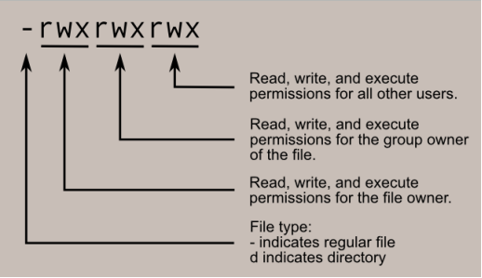

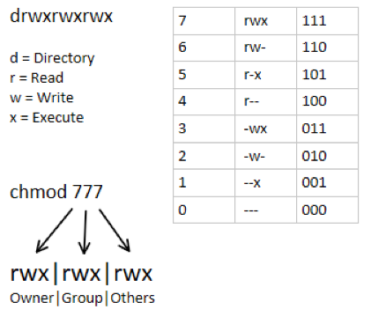

****Example****

#chmod 467 filename.txt

****Description****

User have only read permission

Group has read and write permission

Others has all read, write and execute permissions.

_ Thank you for reading!

_Rajani